* **Install Minikube on AWS Ubuntu, 22.04 LTS**

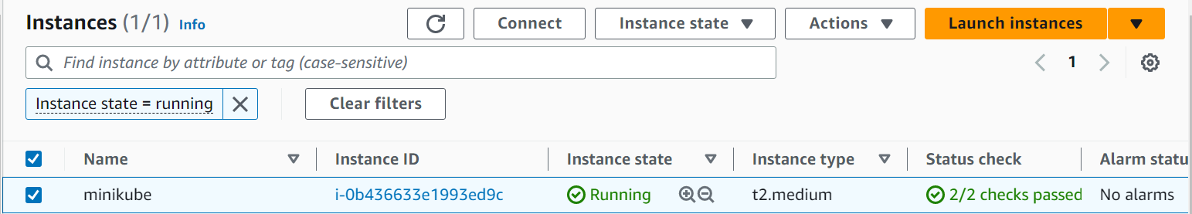

* **Install Docker**
  + sudo apt update -y
  + sudo apt install docker -y
  + sudo usermod -aG docker $USER && newgrp docker
* **Install Minikube**
  + curl -LO https://storage.googleapis.com/minikube/releases/latest/minikube-linux-amd64
  + sudo install minikube-linux-amd64 /usr/local/bin/minikube
  + minikube start
* **Starting Minikube and Testing Installation**

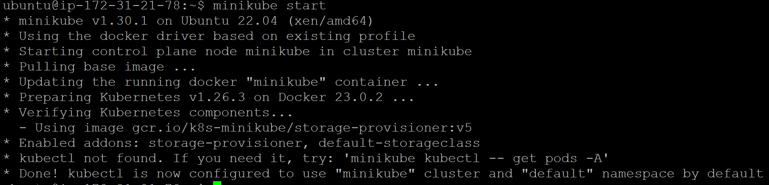

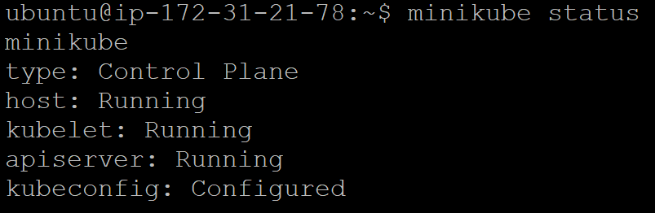

* **Install kubectl**
  + curl -LO [https://dl.k8s.io/release/$(curl -L -s https://dl.k8s.io/release/stable.txt)/bin/linux/amd64/kubectl](https://dl.k8s.io/release/$(curl%20-L%20-s%20https://dl.k8s.io/release/stable.txt)/bin/linux/amd64/kubectl)
  + sudo install -o root -g root -m 0755 kubectl /usr/local/bin/kubectl